

BMI Calculator Website

The purpose with this project was to first-and-foremost learn how to handle website-coding, and secondly to be able to produce a website that other people could access. The project was centred on creating a BMI calculator and sign-in / sign-up site that was linked to a database, by following tutorial videos provided by the teachers.

The development of the various features, such as the calculator, the sign-in, sign-up, etc., was based on various user-stories, e.g. “*As an administrator, I want to be able to view all BMI-calculations on a list.*”

Though we weren’t provided with a concrete background of what kind of company would outsource the development of this kind of website, it seems obvious that it would be for a company centred on health & wellness and/or tackling weight aberrancy.

The following is a list of the user-stories we were provided with (translated to English from Danish, from the instructions found [*here*](https://cphbusiness.mrooms.net/mod/lesson/view.php?id=323702&pageid=4259)):

* **US-1: “*As a user, I want to be able to register additional information, when I perform a calculation, such as gender, age, sport-interest. My choices should be shown on the result-page.*”**
* **US-2: “*As an administration, I want the*** *‘****Calculate’ button to save users’ data and the timestamp to a database.*”**
* **US-3: “***As an administrator, I want to be able to view all BMI-calculations on a list.*”
* **US-4: “*As a visitor, I want to be able to sign-up as a user on the website, so that I can later view my history of calculations.*”**
* **US-5: “*As a logged-in user, I want to be able to view my own calculations.*”**
* **US-6: “*As an administrator, I want to be able to view a list with all the available sport-interests, so that I can keep an overview of all the options.*”**
* **US-7: “*As an administrator, I want to be able to remove a sport-interest, if it hasn’t been selected by any user, to avoid clogging the frontpage dropdown-list with unwanted choices.*”**
* **US-8: “*As an administrator, I want to be able to edit a sport-interest, i.e. the name, to potentially correct mistakes.*”**

To make the website, we used:

* Digital Ocean and Tomcat9 to host it online and make it available to anyone with the link.
* IntelliJ to write the Java and HTML code.
* MySQL to handle the Database.
* GitBash to access our Digital Ocean droplet and handle the virtual-machine versions of Tomcat, our IntelliJ code, and the MySQL database, as well as monitoring the website’s status and such.

**Activity Diagram:**

-insert activity diagram here please-

**Domain Model & EER Diagram:**

-insert domain model here please-

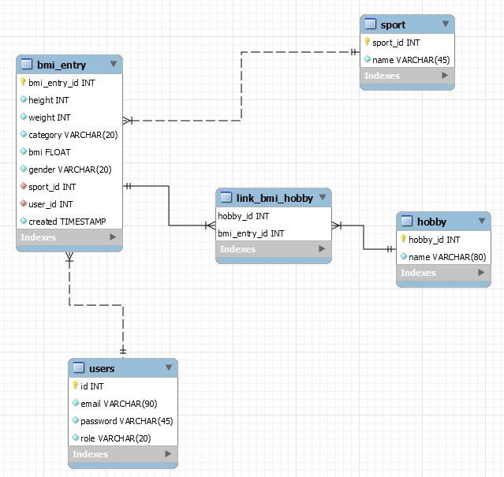

**Navigation Diagram:**

-insert navigation diagram here please-